**The Million Dollar Equation**

**An intriguing puzzle that will keep you awake at night**



Photo by [Craig Whitehead](https://unsplash.com/@sixstreetunder?utm_source=medium&utm_medium=referral) on [Unsplash](https://unsplash.com?utm_source=medium&utm_medium=referral)

This unsolved mystery is one of those problems that are easy to understand but incredibly hard to solve.

In fact, it is so hard that **D. Andrew Beal**, a prominent banker who is also a mathematics enthusiast, has funded a prize of a million dollars for a correct solution to the problem.

In mathematics, there are many problems that are so important that they come with a money prize.

The most well-known such problems are the 7 Millenium problems which include famous problems like *The Riemann Hypothesis* and *P vs NP*.

However, there are other problems out there with prices on their heads. The problem referred to at the top is called *the Beal Conjecture* and that problem is the focus of this article.

**Coprime integers**

Two integers *n* and *m* are said to be **coprime** or **relatively prime** if their **greatest common divisor** is 1.

That is, they have no prime factors in common.

A pair *(n, m)* of coprime integers is called a coprime pair.

It is clear that all pairs of (non-equal) prime numbers are coprime pairs but so is *(9, 4)* for example because no prime number divides both of them.

Recall that a prime number is any positive integer greater than 1 such that 1 is the only positive divisor.

**The Conjecture**

The Beal Conjecture states the following:

Let

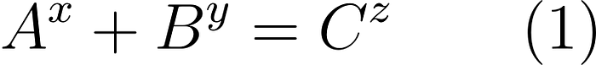

where *A, B, C, x, y* and *z* are natural numbers (positive integers).

If *x, y* and *z* are all greater than *2*, then *A, B* and *C* have a common prime factor.

That’s it!

An example equation is the following:

3³ + 6³ = 3⁵.

Note that in this equation, all the three terms have the prime *3* as a factorsince *3* divides *3*, *6* and *3* respectively.

The Beal Conjecture says that this is always the case.

A nice way to understand any problem of the form *“if P then Q"* is to consider equivalent formulations such as the contrapositive representation of the statement.

The contrapositive statement has the same truth value as the original statement so a proof of the contrapositive would prove the original statement immediately (and vice versa).

The contrapositive statement of the Beal conjecture states the following:

Let equation (1) hold and let *A, B, C, x, y* and *z* be natural numbers (positive integers).

If A, B and C are pairwise coprime (that is they don’t share a prime factor) then either *x, y* or *z* must be *1* or *2*.

We can use the contrapositive Beal Conjecture to form an equation that forces the equation to be true with *A, B* and *C* coprime, as well as *x, y z* greater than *2*.

The conjecture then states that this equation has no natural number solutions.

First, we need Bézout’s identity:

Let a and b be integers with greatest common divisor d. Then there exist integers x and y such that ax + by = d.

We will use a more specialized version of Bézout’s identity restricting it to coprime integers.

We could say that a corollary to Bézout’s identity is the following:

Let *a* and *b* be coprime natural numbers. Then there exist integers *n* and *m* such that *na + mb = 1*.

Note that the converse is also true since if there exist integers *n* and *m* such that *na + mb = 1*, and *a* and *b* are *not* coprime, then they have a common prime factor *p* which is greater than 1 by definition of the prime numbers.

This implies that *p* divides 1 which is clearly a contradiction. Thus *a* and *b* are coprime.

We can now state the following:

Let *a* and *b* be natural numbers. *a* and *b* are coprime *if and only if* there exist integers n and m such that na + mb = 1.

Note that if we know that the Beal equation (1) holds, then the statement “A, B and C does *not* share a common prime factor" is equivalent to the statement A and B are coprime.

This is because if A and B have a common prime factor *p*, then we can factor that out from the left-hand side of (1). This shows (by dividing through by *p*)that C^z has p as a prime factor as well (i.e. *p* divides it). But then it must divide *C* too.

So if *A* and *B* have a common factor, then all of them have that factor.

The contrapositive of this is:

If *A, B* and *C* do not share a common factor and equation (1) holds, then *A* and *B* are coprime.

We can now combine two equations ensuring that they both hold by squaring:

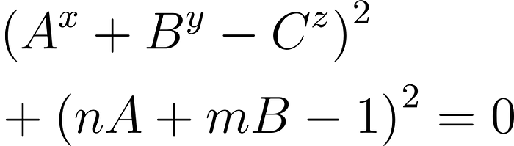

If any solution exists for this equation for natural numbers *x, y, z, A, B, C* and integers *n* and *m*, then at least one of *x, y* or *z* is either *1* or *2*.

If you can prove this, then you’ll get a million dollars.

**The Connection to Fermat’s Last Theorem**

Well, as with everything in this world, there is no easy way of getting a million dollars.

First of all, the proof needs to be published in a peer-reviewed magazine recognized by [*AMS*](https://www.ams.org/home/page).

Secondly, there is a reason why this conjecture is so hard to prove.

It turns out that the Beal conjecture is a generalization of *Fermat’s Last Theorem (FLT)*.

FLT states that there are no natural number solutions to the equation

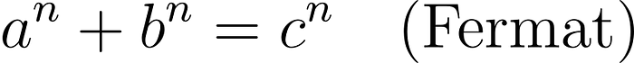

for n ≥ 3.

Fermat’s Last Theorem took mathematicians 350 years to prove and the proof was long, complicated and relied on modern specialized mathematics. In fact, the proof is so complicated that it can only be understood by a handful of people on this planet.

The Beal Conjecture is, in every sense of the definition of the word, harder than FLT!!!

So unless you find a proof by a completely different approach that has been overlooked for 350 years by the best mathematicians in the world, a proof of the Beal Conjecture seems out of reach to say the least.

To see that BC is a generalization of FLT we need to show that BC => FLT.

That is if the Beal Conjecture is true then Fermat’s Last Theorem is true.

Of course, we know that FLT *is* true because of the above-mentioned proof by *Andrew Wiles* via the Modularity Theorem which can be seen informally as a bridge or dictionary between the world of elliptic curves and the world of modular forms.

An astounding achievement indeed!

However, we want to prove that even if we didn’t know about Andrew’s proof, the Beal Conjecture would still imply Fermat’s Last Theorem.

To see this assume that the BC is true and that a Fermat equation like the one above holds for natural numbers a, b, c and some natural number exponent *n* with *n ≥ 3*.

Then by BC, we know that a, b and c have a common factor *p*. We can now divide through by p^n to obtain yet another solution to FLT.

By continuing dividing through by common primes to the *n*th power, we will eventually get a solution with a and b coprime.

This contradicts the assumption of the Beal Conjecture, thus there can be no such solution for *n ≥ 3* i.e. Fermat’s Last Theorem.

The Beal Conjecture is a fascinating mystery of numbers. Like Fermat’s Last Theorem it appeals to us because of its simple looks, but as we now know, looks can be deceiving…